**SUMMER INTERNSHIP REPORT**

***Submitted by***

KV ALEKHYA

PRAGNYA PATIL

***In partial fulfilment of summer internship for the award of the degree***

***Of***

**BACHELOR of ENGINEERING**



**MS RAMAIAH INSTITUTE OF TECNOLOGY**

**BANGALORE, KARNATAKA-560084**

**ACKNOWLEDGEMENT**

I take this opportunity in expressing my heart full gratitude to ***Ms. Iswarya*** (HR) for allowing me to pursue the internship at ***Greenko Group***.

A special debt of gratitude is owed to ***Ms. Durga Bhavani*** and **Mr. Malleswararao** for their encouragement. They were also the sole driving force by extending constant support and continuous feedback for the progress of the Project.

I would also like to thank ***Mr.Vamsi Mohan*** for his valuable time and support.

***KV ALEKHYA***

***PRAGNYA PATIL,***

***B.E 3th Year,***

***BACHELOR OF ENGINEERING,***

***RAMAIAH INSTITUTE OF TECHNOLOGY,***

***BANGALORE, KARNATAKA***

Table of contents

1. Basic Solar Jargon
2. Earth’s Tilt
3. Photovoltaic effect
4. Types of Modules
5. Types of Inverters
6. Loses in solar power plants
7. Breakdowns
8. Kondamallepally Government Bay Extension (Sub-station) 220/132KV:
9. Zuka Power Private Limited

10.Time series analysis and forecasting

**Basic Solar Jargon**

# General Angles

Table 1.0 General Angles

# Earth – Sun angles

Table 1.1 Earth-Sun Angles

# Sun observer angles

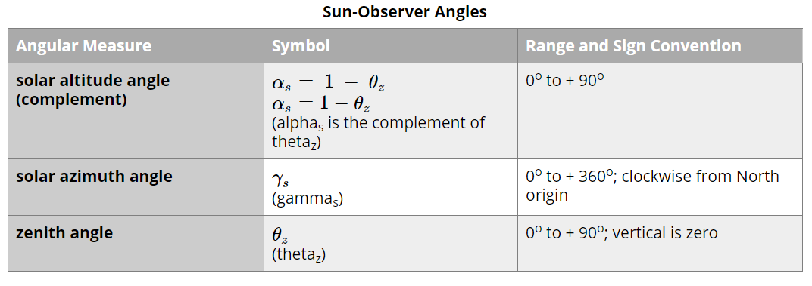

Table 1.2 Sun Observer Angles

# Collector sun angles

Table 1.3 Collector-Sun Angles

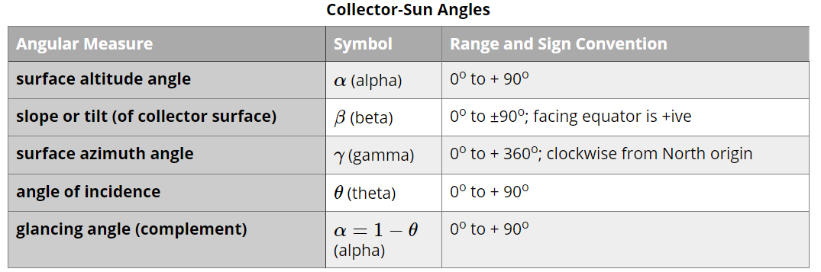

**Earth’s tilt**

The tilt of the earth's axis is important, in that it governs the warming strength of the Sun's energy. The tilt of the surface of the Earth causes light to be spread across a greater area of land, called the cosine projection effect. It is known that the Earth's Tilt Causes the Seasons. The angle of the sun's rays not only creates temperature differences across Earth, but it's also responsible for the seasons in temperate regions. Contrary to popular belief the earth is not the farthest from the sun during winter months.

The earth is actually closer to the sun when the Northern Hemisphere is experiencing winter but is just tilted away from the sun. This means that in the Northern Hemisphere, the sun's rays act more like the tilted flashlight during the winter and more like the right-angle flashlight during the summer. The opposite is true for the Southern Hemisphere.

# Earth's Rotation

The Earth rotates with a roughly constant speed, every hour the direct beam ,a ray pointing from the surface of the Sun to a spot on Earth, will traverse across a single standard meridian, standard meridians are spaced 15° apart. The implications are that the unit of **one hour** is equivalent to the rotation of Earth 15 degrees. When Earth rotates such that the beam of the sun shifts +1° of longitude from East to West: it takes **4 minutes** of time.

* 1 h = +15° Earth rotation
* 4 min = +1° Earth rotation

**.**

The axis of rotation of the Earth is tilted at an angle of 23.5 degrees away from vertical, perpendicular to the plane of our planet's orbit around the sun.

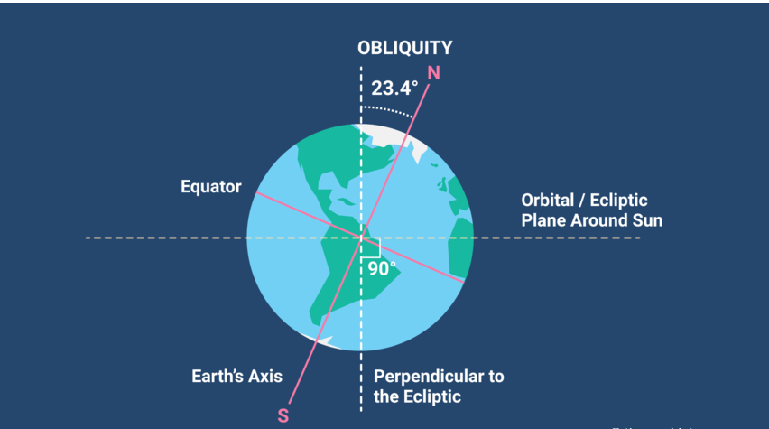The tilt of the earth's axis is important, in that it governs the warming strength of the Sun's energy. The tilt of the surface of the Earth causes light to be spread across a greater area of land, called the **cosine projection effect.**

Figure Earth’s Tilt

**Photovoltaic effect**

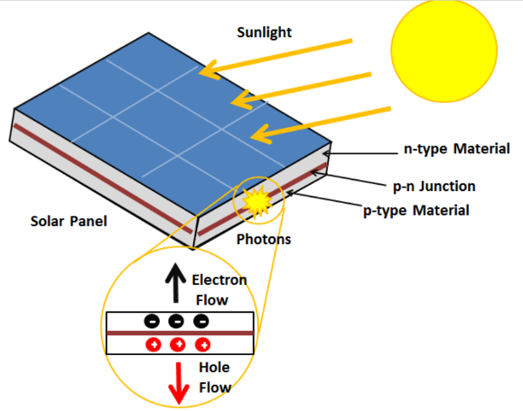The photovoltaic effect is a process that generates voltage or electric current in a photovoltaic cell when it is exposed to sunlight. It is this effect that makes solar panels useful, as it is how the cells within the panel convert sunlight to electrical energy. The photovoltaic effect was first discovered in 1839 by Edmond Becquerel. When doing experiments involving wet cells, Becquerel noted that the voltage of the cell increased when its silver plates were exposed to the sunlight. The photovoltaic effect occurs in solar cells. These solar cells are composed of two different types of semiconductors - a p-type and an n-type - that are joined together to create a p-n junction. To read the background on what these semiconductors are and what the junction is, click here. By joining these two types of semiconductors, an electric field is formed in the region of the junction as electrons move to the positive p-side and holes move to the negative n-side. This field causes negatively charged particles to move in one direction and positively charged particles in the other direction. Light is composed of photons, which are simply small bundles of electromagnetic radiation or energy. These photons can be absorbed by a photovoltaic cell - the type of cell that composes solar panels.When light of a suitable wavelength is incident on these cells, energy from the photon is transferred to an atom of the semiconducting material in the p-n junction. Specifically, the energy is transferred to the electrons in the material. This causes the electrons to jump to a higher energy state known as the conduction band. This leaves behind a "hole" in the valence band that the electron jumped up from. This movement of the electron as a result of added energy creates two charge carriers, an electron-hole pair. When unexcited, electrons hold the semiconducting material together by forming bonds with surrounding atoms, and thus they cannot move. However in their excited state in the conduction band, these electrons are free to move through the material. Because of the electric field that exists as a result of the p-n junction, electrons and holes move in the opposite direction as expected. Instead of being attracted to the p-side, the freed electron tends to move to the n-side. This motion of the electron creates an electric current in the cell. Once the electron moves, there's a "hole" that is left. This hole can also move, but in the opposite direction to the p-side. It is this process which creates a current in the cell.

Figure Photovoltaic Cell

The corrosion of the transparent conductive layer of the panel occurs when moisture penetrates around module edges. This specially can happen in thin film PV panels which are frameless, manufactured based on glass substrates. Since the moisture penetrates into the modules, dark areas appear, starting in the outer zone of the module and depending of the severity, extends to the rest of the surface. When this happens, the under performance of the module is normally linear dependent with the corroded areas dark areas present in the panel.

**Types of Modules:**

1. Monocrystalline Solar Panels (Mono-SI):

* These are the purest form of solar panels, hence their high efficiency/performance rates.
* Monocrystalline solar cells are cut from a single, pure crystal of silicon i.e. the ingot which is then sliced thinly into silicon wafers. The wafer is made into the cell, and then the cells are assembled together to form a solar panel.
* Monocrystalline solar cells appear black because of the way sunlight interacts with pure silicon. The monocrystalline cells are shaped like a square with the corners removed, so there are small gaps between the cells.

1. Polycrystalline Solar Panels (p-Si):

* They are composed of fragments of silicon crystals that are melted together in a mold before being cut into wafers.
* Polycrystalline cells are blue in colour because of the way sunlight reflects on the crystals. Sunlight reflects off of silicon fragments differently than it does with a pure silicon cell. The shape of the cell is a square, and there are no gaps between corners of cells.

1. Thin-film solar panels:

* They aren’t always made from silicon. They can be made from a variety of materials, including cadmium telluride (CdTe), amorphous silicon (a-Si), and Copper Indium Gallium Selenide (CIGS).
* Manufacturers place a layer of CdTe between transparent conducting layers that help capture sunlight. This type of thin-film technology also has a glass layer on the top for protection.
* Can also be made from amorphous silicon (a-Si), these thin-film panels use silicon in their composition, they are not made up of solid silicon wafers. Rather, they’re composed of non-crystalline silicon placed on top of glass, plastic, or metal.
* These panels are approximately 350 times thinner than those that use silicon wafers.

|  |  |  |  |
| --- | --- | --- | --- |
| **Factor** | **Monocrystalline** | **Polycrystalline** | **Thin film** |
| Efficiency | Reaches 20% efficiency | Reaches 15-17% efficiency | Reaches 11% efficiency |
| Temperature coefficient | -0.3% / °C to -0.5% / °C | -0.3% / °C to -0.5% / °C | -0.2% / °C |
| Cost | Most expensive | Fairly lower costs | Least expensive. |
| Life span | 25-40 years | 25 years | Shorter life span |

# **Types of Inverters:**

1. String Inverter:

* String inverters can be mounted on walls or the ground, and typically weigh between 120 and 160 pounds apiece, which is light for the high level of functionality they pack.
* They group individual solar panels together via connective strings – with one inverter for each set of panels – and perform DC-to-AC conversions for all of them. There are notable advantages stemming from this core design.
* The advantages include modularity, low upfront costs and flexible applications. For example, multiple string inverters can be affordably installed on a project, and if one of them goes down it's straightforward to replace it with a new one. Overall, maintenance is simple because there aren't numerous moving parts.
* Depending on the use case, string inverters can be deployed in sizes from approximately 36 to 125 kilowatts (kW). They are also useful across a variety of rooftop, carport, ground mount and tracker installations

1. Central Inverter:

* Central inverters are much larger than string inverters. Sizes may range from 125 kW to 2.5 MW, with even the smallest variants much larger than the biggest string inverters.
* Whereas string inverters are mainstays of both commercial and residential solar projects, central inverters are exclusive to utility-scale applications. Common environments for central inverter utilization are industrial facilities, large buildings and field arrays.

The massive scale of central inverters confers several distinctive advantages, including:

* Great suitability for utility-scale ground-mounts, behind-the-fence applications and systems with consistent production across arrays.
* Cost-effective, at least when measured by capital price per DC watt compared to string inverters.
* Straightforward installation, since some projects will only need a single unit and there are fewer overall component connections than with typical string inverter layouts.

At the same time, installation is usually expensive and compounded by higher-cost combiners and DC wires. A central inverter also has a large footprint and may require more maintenance than string inverters because of the greater overall number of parts. Failure of a central inverter will be more consequential than any incident affecting a single string inverter.

**Losses in Solar Power Plants**

# **Heat loss in PV modules**

The operating temperature of a PV module is an equilibrium between the heat generated by the PV module and the heat loss to the surrounding environment. There are three main mechanisms of heat loss: conduction, convection and radiation.

### Heat Conduction

Conductive heat losses are due to thermal gradients between the PV module and other materials (including the surrounding air) with which the PV module is in contact. The ability of the PV module to transfer heat to its surroundings is characterized by the thermal resistance and configuration of the materials used to encapsulate the solar cells.

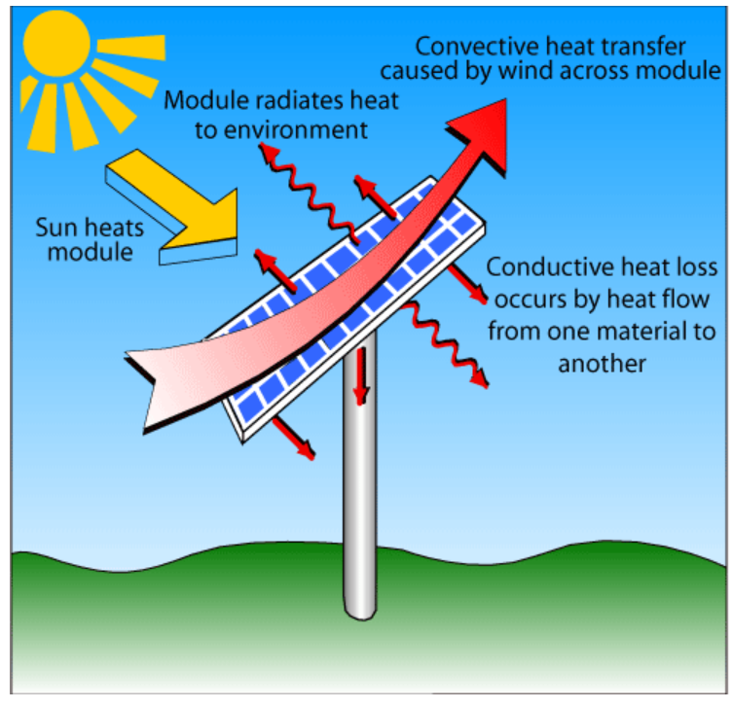Conductive heat flow is analogous to conductive current flow in an electrical circuit. In conductive heat flow, the temperature differential is the driving force behind the conductive flow of heat in a material with a given thermal resistance, while in an electric circuit the voltage differential causes a current flow in a material with a particular electrical resistance.

Therefore, the relationship between temperature and heat (i.e., power) is given by an equation similar to that relating voltage and current across a resistor. Assuming that a material is uniform and in a steady state, the equation between heat transfer and temperature is given by: $∆T= φP_{heat}$

Figure Panel Losses

where:

Pheat is the heat (power) generated by the PV module discussed in Heat Generation in PV Modules;

Φ is the thermal resistance of the emitting surface in °C W-1; and

ΔT is the temperature difference between the two materials in °C.

Convection

Convective heat transfer arises from the transport of heat away from a surface as the result of one material moving across the surface of another. In PV modules, convective heat transfer is due to wind blowing across the surface of the module. The heat which is transferred by this process is given by the equation:

$$P_{heat}=hA∆T$$

where:

A is the area of contact between the two materials;

h is the convection heat transfer co-efficient in units of W m-2 °C-1; and

ΔT is the temperature difference between the two materials in °C.

Radiation

A final way in which the PV module may transfer heat to the surrounding environment is through radiation. As discussed in the Blackbody Radiation page, any object will emit radiation based on its temperature. The power density emitted by a blackbody is given by the equation:

$$P =σT^{4}$$

where:

P is the power generated as heat by the PV module;

σ is the Stefan-Boltzmann constant as given in the Constants page; and

T is the temperature of the solar cell in K.

However, a PV module is not an ideal blackbody and to account for non-ideal blackbodies, the blackbody equation is modified by including a parameter called the emissivity, ε, of the material or object. A blackbody, which is perfect emitter (and absorber) of energy has an emissivity of 1. An emissivity of an object can often be gauged by its absorption properties, as the two will often be very similar. For example metals, which tend to have reduced absorption, also have a lower emissivity, usually in the range of 0.03. Including the emissivity in the equation for emitted power density from a surface gives:

$$P =εσT^{4}$$

where:

$ε$ is the emissivity of the surface; and

the remainder of the parameters are as above.

The net heat or power lost from the module due to radiation is the difference between the heat emitted from the surroundings to the module and the heat emitted from the PV module to the surroundings, or in mathematical format:

$$P =εσ(T_{sc}^{4}-T_{amb}^{4}$$

where:

$T_{SC}$ is the temperature of the solar cell;

$T_{amb}$ is the temperature of the ambient surrounding the solar cell; and

the remainder of the parameters are as above.

# The Temperature Coefficient

In the data sheet provided by a solar panel manufacturer, a term normally described as the temperature coefficient pMax is referred to. This value, which is normally given in the form of negative percentage, reveals the impact of temperature on the panel.

Solar panels are power tested at 250C, the temperature coefficient percentage illustrates the change in efficiency as it goes up or down by a degree. If the temperature coefficient of a particular type of panel is -0.5%, then for every 10C rise, the panels maximum power will reduce by 0.5%.

On a hot day, when panel temperatures may reach 450 C a panel with a temperature coefficient of -0.5% would result in a maximum power output reduction of 10%. Conversely, if it was a sunny winter’s morning, the panels will actually be more efficient.

Each type of solar cell has a different temperature coefficient is detailed below:

1. Both monocrystalline and polycrystalline cells have a temperature coefficient pMax of between -0.45% to -0.50%
2. Amorphous based thin film panels have a rating of between -0.20% to -0.25%.
3. The Hybrid solar cells currently on the market sit in the middle with a temperature coefficient pMax of between -0.32

**Breakdowns**

Panel Breakdowns

# Hotspot

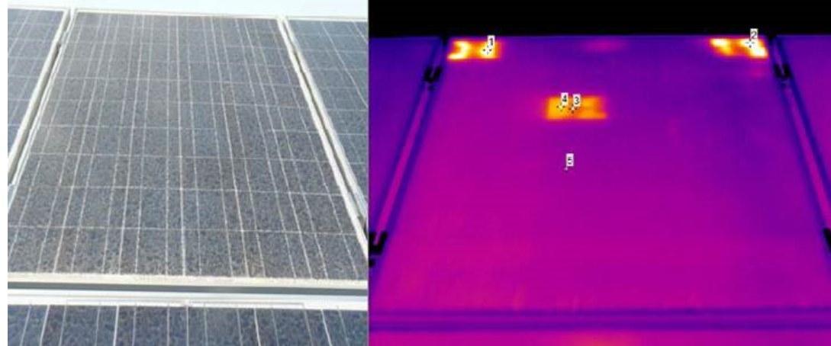Solar cells are designed to generate an electric current when the sunlight shines upon them.When the current flows through the solar cell strings within panels, the resistance in cells converts the current into heat losses.Any imperfection in solar cells, such as cracks, poorly soldered joints, and mismatches, lead to higher resistance and become hot spots in the long run.The long term effects of hot spots include burnt marks that degrade solar cells and backsheets and may eventually lead to fires if left unchecked. Hot spots in PV panels are mainly caused by bad soldered connection points or structural defects in the solar cells. These wrong connections cause regions of the panel with very low resistivity and finally gets part of the current that must be generated by the cell in normal conditions. These currents can be elevated and produce hot spots in the welded point and/or inside a cell. This phenomenon can generate short circuits, and in both cases, it reduces the performance and the lifecycle of the PV panel.

Figure Panel Hotspot

Microcracks

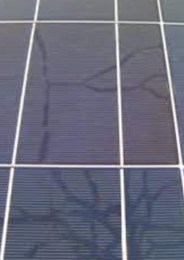Low-cost solar cells can have structural defects which are not visually detectable, these defects are known as microcracks. Due to the self- performance effect of the PV module, thermal cycles happen in the module during transitions between day/night and different seasons of the year. These defect can generate damages in the cell contact points to evacuate the current. In this scenario, a solar cell could be severely damaged. Even though cells have serial connection inside the PV modules, this will limit the current of the whole panel and consequently reduce the whole module performance proportionally to the number of cracked cells.

Figure Solar Panel Micro Cracks

PID effect

PID stands for “Potential Induced Degradation”. This phenomenon occurs when there is a relative voltage with regard to PV panel ground connection. Although, for safety reasons, PV panel frame is normally connected to ground, a relative voltage between ground voltage, and voltage generated by a solar panel could exist. In some cases, this generates a voltage field which partially discharges the current generated by the panel. The consequence of this effect, is the continuous performance degradation and the accelerated aging of the PV panel.

Improper installation

One of the most simple and common defects at the same time, is the improper installation of PV modules. It must be verified against the design that the right clamps are used, expansion joints respected and mounting structures appropriated and correctly oriented. Otherwise, modules can break or even fly away in some cases.

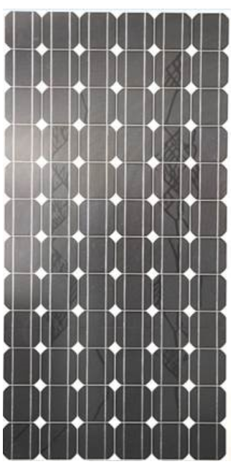Snail tracks

When solar cell has been manufactured with low cost silver paste (used in the front metallization contacts of the solar cells), it is probable that humidity zones appear in the rear part of the module which finally is transmitted to the front part of the module. There is a chemical reaction between silver paste and EVA (“ethyl-vinyl-acetate”) module encapsulant, which liberates silver oxide and hydrogen. This effect is transmitted from the rear part of the panel and produces a chemical degradation in the front part of the solar cell which can affect its performance. Snail track defect position is normally correlated with microcraked cells.

Figure Snail Tracks

BROKEN GLASS MAKES SOLAR CELLS MORE SUSCEPTIBLE TO WEATHER DAMAGES

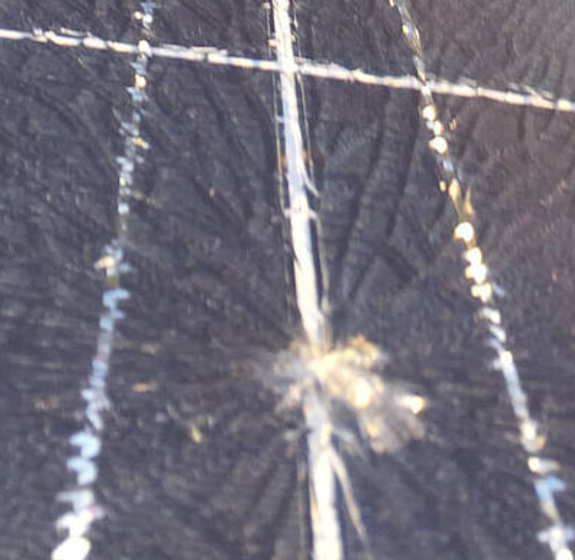The front glass panel of a solar module represents the first line of defence against the weather elements, like rain, dust, hail, and the occasional stray golf ball.

An ideal glass should be strong enough to withstand reasonable stresses like hailstones and golf balls while allowing sunlight to be absorbed by solar cells.

If an understrength glass is broken, not only the light absorbed by the panel will diminish, foreign elements such as water and dust can go under the glass to shade solar cells and impact energy output.

Figure Solar Panel Glass crack

DUST BUILD-UP NEAR PANEL EDGES CAN SHADE SOLAR CELLS

When solar panels are placed on rooftops at a gradual slope, the module frames may collect rainwater into a stagnant pool.

Dust residue is left behind when the water evaporates to create unwanted shade and reduce energy production from solar cells.

Inverter breakdowns

Capacitor wear

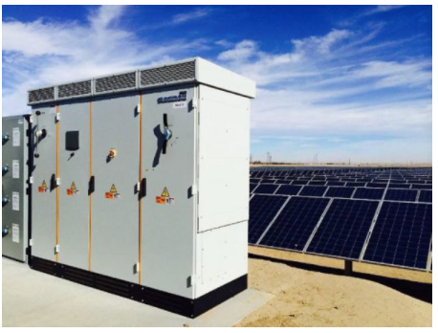The electro-mechanical wear on condensers is the first cause of inverter failure. Inverters rely on condensers to provide a smooth power output at varying current levels; however, electrolyte condensers have a shorter lifetime and age faster than dry components. That can be a cause of inverter failure in itself.

Figure Invertor

The capacitors are also highly sensitive to temperature. Temperatures above the specified operating temperature, often caused by high current, can reduce the component’s durability. However, as the electrolytes evaporate more quickly at higher temperatures, the life of the condenser decreases when operated at lower operating temperatures.

Happily, keeping a consistent maintenance regime and regularly replacing capacitors avoids most problems that failed capacitors can cause.

Overuse

Using inverters past their operating limit, either by choice or owing to negligence or lack of awareness, may lead to the failure of the inverter bridge. Using any device that is higher than its operating limit will decrease its lifetime and result in failure, so avoiding this problem would simply result in ensuring that all inverters are running properly.

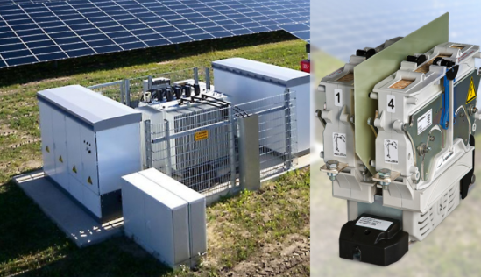Over- and under-voltage

The next two problems that can trigger a failure of the inverter are overcurrent and overvoltage. If either current or voltage rises to a point not rated for by the inverter, this can cause damage to the device’s components, most often the inverter bridge. Sometimes the excess heat produced by the voltage or current spike can cause the harm.

Figure Inventor

Over-current can be stopped with fuses or circuit breakers but it can be difficult to prevent over-voltage. Tension spikes are often man-made, but they can also be triggered by lightning or solar flares which are difficult to stop if you live on planet Earth like us.

Ultrasonic vibrations

The final problem on the list is one that leads to the mechanical stress that an inverter brings. Ultrasonic vibrations originating in the inductive component cores cause friction, contributing to the device’s excessive heat, and further damaging components in the inverter. Maintenance is the key as with any electrical equipment, and must not be ignored. Electrical links tend to fall out or corrode over time. If the inverter is still working, a repair manager can be tempted to simply ignore these wear and tear signs.

Nonetheless, as the saying goes, it is safer to be safe than sorry, so it is important that the terminals in the battery case, fuses and inverter links are washed at least once every six months. In addition, the cleaning process needs to be carried out properly, or it may end up causing more harm than good. Ideally, a brush wire and dissolvent grease agent should be used. A protective sealant must also be used on all battery te rminals until the cleaning and maintenance is complete.

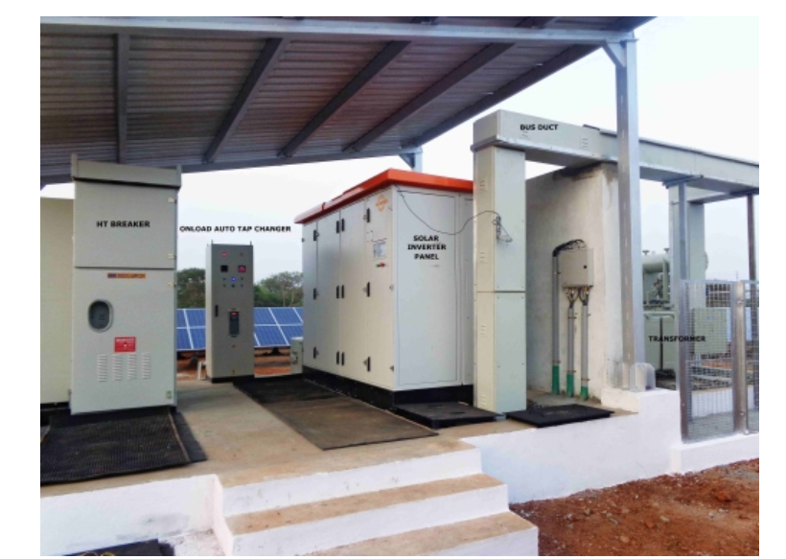Remove grease-based coatings when determining which protective coating to use, as they continue to attract pollutants such as dust, leading to the increased decline of the connections, while also shielding the deterioration from further visual inspections. While proper installation and maintenance will dramatically extend the lifetime of the inverters, there are a few routes you will take when failure happens. Particularly for older or outdated models, the purchasing of a refurbished component may be worth considering.

Figure Invertor

**Kondamallepally Government Bay Extension (Sub-station) 220/132KV:**

The incoming 220KV voltage from the grid substation is stepped down to 132KV using four Step down transformer. 132KV is a level acceptable for the local distribution of the power streams. The 132KV is then distributed to the neighbouring villages, Sterling Wilson plant, Mitra solar power plant and Zuka power plant.

Equipment at the plant:

1. Autotransformer:

* Substation autotransformers transfer the incoming high voltage to the next lower voltage level. In this case, incoming high voltage of 200 kV would be transferred down to 132 kV.
* In general substation autotransformers are equipped with on-load tap-changers (OLTC). Incoming transmission lines are connected to the transformers through bushings and cables through cable boxes and cable sealing ends.
* Autotransformers are built in core form with auto connected windings, ie common main winding and a separate low voltage winding.

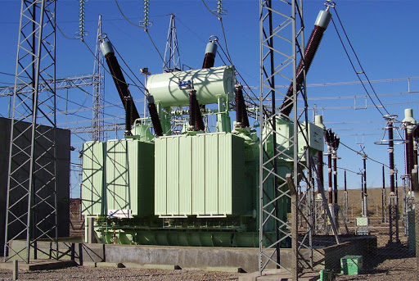

Figure: Step-down Transformer (200Kv to 132kV)

1. Main and Check meters:

* The main, check and standby meters are Electronic tri-vector meters measure the three vectors namely active, reactive and apparent power of a line. They can measure power as well as energy.
* The Tri-vector enables the simultaneous measurement of different electrical parameters like current (IR, IY, IB) and voltage (VRN, VYN, VBN) etc which enables accurate assessment of the power consumed.
* They are used for billing power drawn by industrial customers.
* They are connected directly to the voltage and current transformers.
* They also receive the plant readings which are relayed to the meters. They serve as reference for Joint measurement readings which are cross checked by the government for accountability and vigilance purposes.

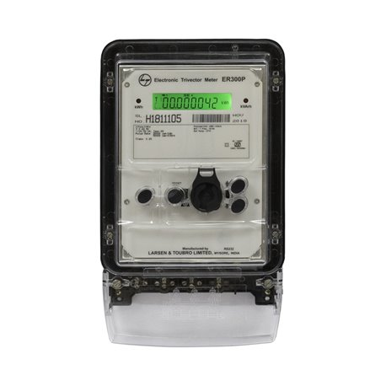

Figure: Electronic Tri-Vector Meter

1. NMD Tower:

* It is a three-circuit tower which is used to carry high voltage [transmission lines](https://www.electrical4u.com/electrical-power-transmission-system-and-network/) that transport bulk electric power from substation to plant substation.

1. Lightning arresters:

* Lightning arrester diverts the abnormal high voltage to the ground without affecting the continuity of supply. It is connected between the line and earth, i.e., in parallel with the equipment to be protected at the substation. It diverts the lightning, limits the voltage and protects the equipment installed in parallel.

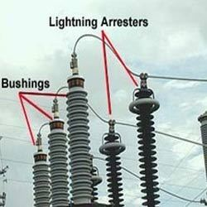

Figure: Lightning Arrester

1. Capacitor voltage transformer (CVT):

* A capacitor voltage transformer (CVT) is a transformer used in power systems to step-down extra high voltage signals and provide low voltage signals either for measurement or to operate a protective relay.
* In its most basic form, the device consists of three parts: two capacitors across which the voltage signal is split, an inductive element used to tune the device to the supply frequency and a transformer used to isolate and further step-down the voltage for the instrumentation or protective relay.
* The CVT is also useful in communication systems. CVTs in combination with wave traps are used for filtering high-frequency communication signals from power frequency. This forms a [carrier communication network](https://en.wikipedia.org/wiki/Power_line_carrier_communication) throughout the transmission network, to communicate between substations. The CVT is installed at a point after [Lightning Arrester](https://en.wikipedia.org/wiki/Lightning_arrester) and before [Wave trap](https://en.wikipedia.org/w/index.php?title=High-frequency_line_trap&action=edit&redlink=1).

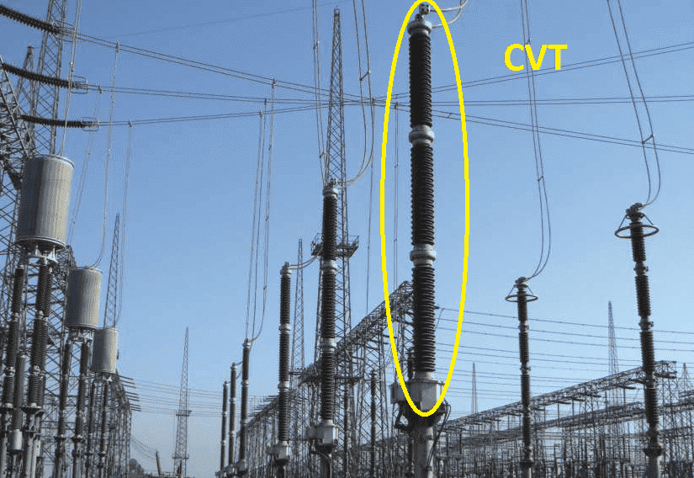

Figure: Capacitor Voltage Transformer

1. Power-line carrier communication (PLCC)

* Power-line carrier communication (PLCC) is mainly used for [telecommunication](https://en.wikipedia.org/wiki/Telecommunication), tele-protection and tele-monitoring between [electrical substations](https://en.wikipedia.org/wiki/Electrical_substation) through [power lines](https://en.wikipedia.org/wiki/Power_line) at [high voltages](https://en.wikipedia.org/wiki/High_voltage), such as 110 kV, 220 kV, 400 kV.
* Carrier protection relaying of transmission line so that: Inner trip command can be issued by relay due to tripping of circuit breaker at any one end
* Station to station communication between operating personal.
* Carrier telemetering: Electrical quantities that are telemetered are apparent power, active power and reactive power, voltage, power factor etc.

1. Line Isolator:

* It isolates two different parts of an instrument.  Isolators separate a certain circuit from the electricity mains and discharge any residual current, left in the circuit, to the ground.
* The main purpose of an isolator is safety because if a fault occurs in one section of a circuit or [power supply](https://www.watelectrical.com/what-is-a-power-supply-and-types-of-power-supply-for-electrical-circuits/) then electrical isolator is used as a switch to keep apart that section from other sections of system to perform repair work.
* Isolator are sometimes used as switches that can be opened or closed based on the requirement
* The line isolators are used to isolate the high voltage from flow through the line into the bus.

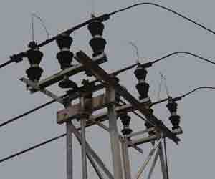

Figure: Line Isolator

1. Metering Potential Transformers:

* The potential transformer may be defined as an instrument transformer used for the transformation of voltage from a higher value to the lower value. This transformer step down the voltage to a safe limit value which can be easily measured by the ordinary low voltage instrument like a **voltmeter, wattmeter and watt-hour meters**, etc.
* There are six MPT’s in the substation to measure the voltages, for the protection of the feeders, for protecting the impedance of the generators and for synchronising the generators and feeders.

1. Metering Current Transformers:

* A current transformer is a device that is used for the transformation of current from a higher value into a proportionate current to a lower value. It transforms the high voltage current into the low voltage current due to which the heavy current flows through the [transmission lines](https://circuitglobe.com/transmission-lines.html)is safely monitored by the **ammeter**.
* There are six MCT’s in the substation to measure the current going out through the feeder.

1. 132kV circuit breaker (Sulphur Hexafluoride (SF6) Circuit Breaker):

* The use of SF6 circuit breaker is mainly in the substations which are having high input kv input, say above 220kv and more.
* In the normal operating conditions, the contacts of the breaker are closed. When the fault occurs in the system, the contacts are pulled apart, and an arc is struck between them. The displacement of the moving contacts is synchronised with the valve which enters the high-pressure SF6 gas in the arc interrupting chamber at a pressure of about 16kg/cm^2.
* The SF6 gas absorbs the free electrons in the arc path and forms ions which do not act as a charge carrier. These ions increase the dielectric strength of the gas and hence the arc is extinguished.
* It acts as an ON/OFF switch and can be used for the maintenance for the MCT’s and MPT’s.

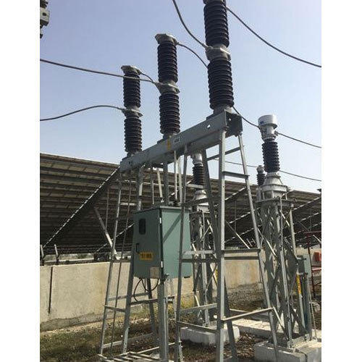

Figure: SF6 circuit breaker

1. Bus Isolator:

* The isolator is directly connected with main bus.
* It can be shut down for the maintenance of the MPT’s, MCT’s, Lightning arresters and CVT and when the circuit beaker breaks down.

1. Bus:

* The bus is a line in which the incoming feeders come into and get into the instruments for further step up or step down.
* There may be double line in the bus so that if any fault occurs in the one the other can still have the current and the supply will not stop. The two lines in the bus are separated by a little distance having a connector between them. This is so that one can work at a time and the other works only if the first is having any fault.

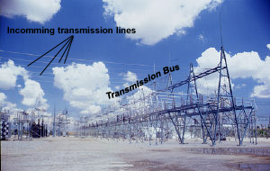

Figure: Bus

Figure: Line diagram with capacity of respective instruments

**Zuka Power Private Limited**

Power distribution and generation in the plant

1. Module:
2. Specifications:
3. Risen Solar Technology-RSM72-6-320P
4. 72 cells make up a single module.
5. The modules currently being used are Polycrystalline solar modules.
6. Voltage at Pmax (Vm) = 37.30V
7. Current at Pmax (Im) = 8.60A
8. Rated maximum power (Pmax) = 320W
9. PV cell:

* A **solar cell** is defined as an electrical device that converts light energy into [electrical energy](https://www.electrical4u.com/source-of-electrical-energy/) through the [photovoltaic effect](https://www.electrical4u.com/what-is-photovoltaic-effect/). A solar cell is basically a [p-n junction diode](https://www.electrical4u.com/p-n-junction-diode/). Solar cells are a form of photoelectric cell, defined as a device whose electrical characteristics – such as [current](https://www.electrical4u.com/electric-current-and-theory-of-electricity/), [voltage](https://www.electrical4u.com/voltage-or-electric-potential-difference/), or [resistance](https://www.electrical4u.com/what-is-electrical-resistance/) – vary when exposed to light.
* Individual solar cells can be combined to form modules commonly known as solar panels or strings. The common single junction silicon solar cell can produce a maximum open-circuit voltage of approximately 0.5 to 0.6 volts.

1. Construction:

* A solar cell is basically a junction [diode](https://www.electrical4u.com/diode-working-principle-and-types-of-diode/), although its construction it is little bit different from conventional p-n junction diodes. A very thin layer of [p-type semiconductor](https://www.electrical4u.com/p-type-semiconductor/) is grown on a relatively thicker [n-type semiconductor](https://www.electrical4u.com/n-type-semiconductor/). We then apply a few finer [electrodes](https://www.electrical4u.com/surface-electrodes/) on the top of the p-type semiconductor layer.
* These electrodes do not obstruct light to reach the thin p-type layer. Just below the p-type layer there is a [p-n junction](https://www.electrical4u.com/p-n-junction-theory-behind-p-n-junction/). We also provide a current collecting electrode at the bottom of the n-type layer. We encapsulate the entire assembly by thin glass to protect the **solar cell** from any mechanical shock.

1. Working Principle of Solar Cell:

* When light reaches the [p-n junction](https://www.electrical4u.com/p-n-junction-theory-behind-p-n-junction/), the light photons can easily enter in the junction, through very thin p-type layer. The light energy, in the form of photons, supplies sufficient energy to the junction to create a number of electron-hole pairs. The incident light breaks the thermal equilibrium condition of the junction. The free electrons in the depletion region can quickly come to the n-type side of the junction.
* Similarly, the holes in the depletion can quickly come to the p-type side of the junction. Once, the newly created free electrons come to the n-type side, cannot further cross the junction because of barrier potential of the junction.
* Similarly, the newly created holes once come to the p-type side cannot further cross the junction became of same barrier potential of the junction. As the concentration of electrons becomes higher in one side, i.e.n-type side of the junction and concentration of holes becomes more in another side, i.e. the p-type side of the junction, the p-n junction will behave like a small battery cell. A voltage is set up which is known as photo voltage. If we connect a small load across the junction, there will be a tiny current flowing through it.

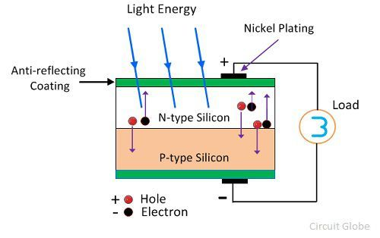

1. Maximum Power Point of Solar Cell:

* The maximum [electrical power](https://www.electrical4u.com/electric-power-single-and-three-phase/) one solar cell can deliver at its standard test condition. If we draw the v-i characteristics of a solar cell maximum power will occur at the bend point of the characteristic curve. It is shown in the v-i characteristics of [solar cell](https://www.electrical4u.com/solar-cell/) by Pm.  
  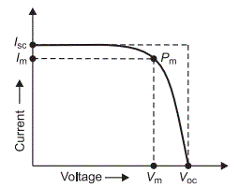
* Current at Maximum Power Point

The current at which maximum power occurs. Current at Maximum Power Point is shown in the v-i characteristics of solar cell by Im.

* Voltage at Maximum Power Point

The voltage at which maximum power occurs. Voltage at Maximum Power Point is shown in the v-i characteristics of solar cell by Vm.

Connecting Solar Panels in Series

* Stringing solar panels in series involves connecting each panel to the next in a line (as illustrated in the left side of the diagram above).
* Just like a typical battery you may be familiar with, solar panels have positive and negative terminals. When stringing in series, the wire from the positive terminal of one solar panel is connected to the negative terminal of the next panel and so on.
* **When stringing panels in series,**[**each panel additional adds to the total voltage**](https://www.solarreviews.com/blog/do-you-wire-solar-panels-series-or-parallel)**(V) of the string but the current (I) in the string remains the same.**

1. Solar Panel:

Six Main Components Of A Solar Panel:

* **Solar photovoltaic cells**
* **Toughened Glass - 3 to 3.5mm thick**
* **Extruded Aluminium frame**
* **Encapsulation - EVA film layers**
* **Polymer rear back-sheet**
* **Junction box - diodes and connectors.**

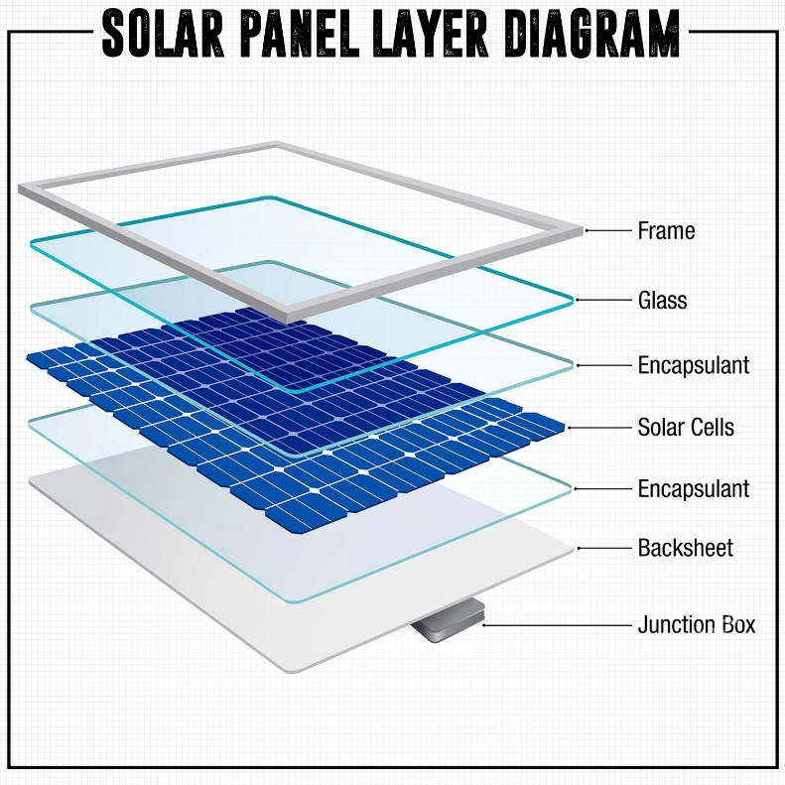

1. String Combiner Box:

* The String Combiner Box combines the multiple DC input coming from the panel termination and converts these into one DC output. It provides additional protection with input fuses & surge protection devices.
* Each string conductor lands on a fuse terminal and the output of the fused inputs are combined onto a single conductor that connects the box to the inverter.
* Solar combiner boxes are engineered to provide overcurrent and overvoltage protection to enhance inverter protection and reliability.
* The combiner box should reside between the solar modules and inverter. When optimally positioned in the array, it can limit power loss.

Specifications:

1. ABB String combiner 100V DC
2. 12 DC inputs
3. Maximum Voltage = 1000V DC
4. Output Voltage DC = 1000V DC
5. Inverter:
6. Specifications:
7. SMA Inverter Sunny Central 1000CP XT
8. Central Inverters are used.
9. 9 DC Inputs
10. Maximum input voltage = 1000 V
11. Nominal AC Voltage = 405 V
12. Solar Inverter:

A solar inverter can be defined as an electrical converter that changes the uneven DC (direct current) output of a solar panel into an AC (alternating current). This current can be used for different applications like in a viable electrical grid otherwise off-grid electrical network. In a PV system, it is a dangerous BOS (balance of system) component that allows the utilization of normal AC powered apparatus.

1. Solar Inverter and it’s Working:

The working principle of the inverter is to use the power from a DC Source such as the solar panel and convert it into AC power. The generated power range will be from 250 V to 600 V. This conversion process can be done with the help of a set of [IGBTs (Insulated Gate Bipolar Transistors)](https://www.elprocus.com/insulated-gate-bipolar-transistor-circuit-and-characteristics/). When these solid-state devices are connected in the form of [H-Bridge](https://www.elprocus.com/h-bridge-motor-control-circuit-using-l293d-ic/), then it oscillates from the DC power to AC power.

1. Central Inverters

These are related to string inverters however they are larger & support additional strings of solar panels. Rather than running strings openly to the inverter, the strings are allied together in a general combiner box so that the DC power runs toward the middle inverter wherever it is transformed to AC power. These inverters needless connections of [components](https://www.elprocus.com/different-methods-of-soldering-the-electronic-components/), however, they need a pad as well as combiner box as they are suitable for huge installations through reliable production across the array.

1. Inverter Duty Transformer:

* It steps up 405-415V AC Output from the inverter to 33kV for transmission to the power transformer
* In power conversion applications an inverter is an electronic transformer that converts power from a Direct Current (D.C.) source into Alternating Current (A.C.) power. Invertor duty transformers, also known as electronic transformers, are commonly used for small power conversion. They are used to get desired voltage levels when the output voltage is low but the desired voltage is high.

1. ICOG (Incoming outgoing shutdown transformer):

* It is used to activate the parameters on the Energy meter and relay data to SCADA.

VII. Double pole yard (33 kV yard):

* 33kV switch yards are generally connected either in one main and one transfer or in single bus scheme.
* 33KV voltage level is either used at grid substation level or at main power receiving point of medium sized industrial Plants.
* ON/OFF- Maintenance of the system right from the IDT.

VIII. Power transformers:

* 50/60MVA
* It is used to step up 33kV coming in from the IDT to 132kV for transmission to the grid.
* The Power transformer is a one kind of transformer, that is used to transfer [electrical energy](https://www.elprocus.com/electrical-energy-saving-tips/) in any part of the electrical or electronic circuit between the generator and the distribution primary circuits. These transformers are used in distribution systems to interface step up and step-down voltages.

SCADA (Supervisory Control and Data Acquisition (SCADA):

1. System architecture:

In a solar PV plant, the SCADA architecture includes:

* One or more master stations or Master Terminal Units (MTUs), which operators use to monitor the plant and interact with remote devices through a Human Machine Interface (HMI). For a solar plant, this will be a computer in the central monitoring station or control room running the SCADA software.
* One or more remote stations, which can be Programmable Logic Controllers (PLCs) and/or Remote Terminal Units (RTUs). These are hardware systems—hardened for outdoor or industrial use—that communicate with substation Intelligent Electronic Devices (IEDs), sensors, HMIs, inverters, trackers and other devices. They can control the processes of these devices, gather their data in real time, and transfer it back to the master station.
* The communications system, which is how the MTU and RTU, as well as all the different devices throughout the plant, connect and communicate with each other. This includes all of the networking hardware.

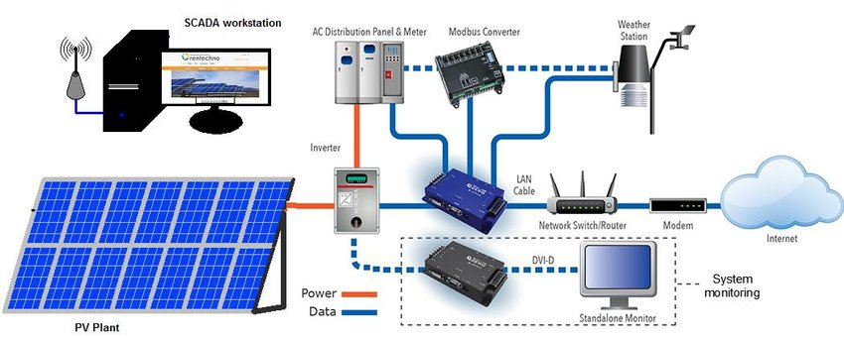

1. Software used: Solarmon
2. Parameters observed:

The data is updated every 15 minutes. The following parameter readings from various devices are collected:

Current generation

POA Irradiance

Current performance ratio CDC Capacity

Current PLF (AC Capacity)

Inverters online, ready, offline and No data

Total number of inverters

From the energy meters: Energy export and import, Voltage (RY, YB , BR), Active and reactive power, Current (R,Y,B), Power factor and Frequency

From Central Inverters: Grid voltage (BR, RY, YB), Power DC, Current (R,Y,B), Active Reactive and Apparent power AC, Daily yield, Power factor.

**Time Series Analysis and Forecasting**

# **Time series and forecasting**

Time series is a series of data points indexed in time order. Time series adds a “time dimension” – an explicit order of dependence between two or more observations. This additional dimension is both a constraint and a structure that provides a source of additional information. To put it concisely, Time series is: An ordered sequence of values of a variable at equally spaced time intervals.

The usage of time series models is twofold:

1. Obtain an understanding of the underlying forces and structure that produced the observed data
2. Fit a model and proceed to forecasting, monitoring or even feedback and feedforward control.

The fitting of time series models can be an ambitious undertaking. There are many methods of model fitting including the following:

1. Box-Jenkins ARIMA models
2. Box-Jenkins Multivariate Models
3. Holt-Winters Exponential Smoothing (single, double, triple)

The user's application and preference will decide the selection of the appropriate technique. Some basic smoothing techniques include:

1. Averaging Methods
2. Exponential Smoothing Techniques.

Time series Analysis

Time series analysis comprises methods for analysing time series data in order to extract meaningful statistics and other characteristics of the data. Time series forecasting is the use of a model to predict future values based on previously observed values.

# **Background and challenges of Forecasting**

Renewable Energy Forecasting is a common procedure among the energy generation companies as forecasting methods provide valuable information about the expected changes in the energy to be generated in the near future to ensure safety to the power grid and maintain sustainable energy production.

Predictions are aiming at providing forecasts using historical time series collected from a certain point, such as a meteorological station, and a wind turbine or a solar panel. In order to further increase the forecasting accuracy, using information from areas close the exact location where the forecasts are performed has gained importance particularly at the last few years.

These methods, namely spatiotemporal forecasting methods, are based on the assumption that weather variables such as wind speed and direction, solar irradiance, and temperature tend to exhibit considerable correlations among the areas close to each other, possibly with time lags depending on several factors such as the distance and elevation difference between the sites.

However here lie the uncertainties in forecasting. Solar power has two main obstacles: energy is produced only during the day times and the energy produced is highly dependent on the weather. Accurate calculations of the amount of solar energy reaching the Earth’s surface under ideal conditions can be made, however, weather fluctuations and the unique microclimate of each location affect current energy production by renewable energy installations.

As regard to Wind energy, several instances of deviations in wind speed and direction make predictions and forecasting more likely inaccurate. Wind power fluctuate over time, under the influence of meteorological conditions. Variations occurs at several scales: seconds (e.g. gusts), hours (e.g. day and night), months (e.g. summer and winder) and so on.

The electricity demand as well is highly variable, changing not only with well-known seasonal and night/day patterns but also incorporating several other variables such as the economic cycles. The grid operator tries to match constantly demand and offer.

They will also need to have a reserve capacity in case of errors in the prediction of the demand or unexpected problem like power plants disconnecting from the grid for whatever problem.

# **Data Collection**

The process of obtaining data involved finding data from a pre-existing data set that contained the following columns:

* Date designations
* Recurring 15-minute Time Intervals
* Actual Power (generated in Mega Watts)
* Predicted Power (generated in Mega Watts)

The details of this data set pertained to:

1. Solar Power Plant “Charanka”
2. Wind Power Plant “Maliya”

To gain more insights from the data, particularly the Actual Power and Predicted Power columns; Deviation, Total Deviation, Deviation Bands, Error Percentage and Penalties were calculated.

# **Calculations:**

(Example Actual Power and Forecast Power values from the Charanka Dataset were taken to determine the calculations performed.)

For the following Values of Actual Power and Predicted Power

|  |  |  |
| --- | --- | --- |
| Actual Power / (MW) | Forecast Power / (MW) | Scheduled Automatic Voltage Control (AVC) / (MW) |
| $$21.12$$ | $$34.81$$ | $$40$$ |

The following are Columns are calculated:

|  |  |  |  |
| --- | --- | --- | --- |
|  | Formula | Excel Formula | Value |
| Deviation  **Column**  (MW) | $$Actual - Forecast$$ | $$=IFERROR(ABS(Actual-Forecast),"0.00")$$ | $$21.12-34.81= 13.69$$ |
| Total Deviation  (KWh) | $$Deviation ×250$$ | $$= Deviation×250$$ | $$13.69 ×250=3422.5$$ |
| Error Percentage | $$\frac{Actual-Forecast}{AVC}×100$$ | =IFERROR(ABS(Deviation/AVC),"0.00") | $$\frac{21.12-34.81}{40}×100=34\%$$ |
| 0 % to 7 % Deviation | (If Error%>0.07) $$ACV ×0.07 ×250$$ (If Error%<0.07) $$Deviation×250$$ | $$=IFERROR(ABS(IF(Error\%>0.07,AVC×0.07,Deviation))×250,"0")$$ | $$40 ×0.07×250=700$$ |
| 7 % to 15 % Deviation | (If Error% >7% to <15%) $$AVC ×\left(Error\%-0.07\right)×250$$ (OR If Error% >15 %) $$AVC ×0.08×250$$ | =ABS(IF(M826>0.07,IF(M826>0.15,H826×0.08,H826×(M826-0.07)),0))×250 | $$40×0.08×250=800$$ |
| 15 % to 23 % Deviation | (If Error% >15% to <23%) $$AVC×\left(Error\%-0.15\right)×250$$ (OR If Error% >23 %) $$AVC ×0.08×250$$ | =ABS(IF(Error%>0.07,IF(Error%>0.15,AVC×0.08,AVC×( Error%-0.07)),0))×250 | $$40×0.08×250=800$$ |
| >23 %  Deviation | $AVC×(Error\%-0.23) ×250$ | =IFERROR(ABS(IF(Error%>0.23,AVC×( Error%-0.23),0))×250,"0") | $$40×\left(0.34-0.23\right)×250= 1122.5$$ |
| Penalty | $$7\%to15\%Deviation×0.25 +15\%to23\%Deviation×0.5 +>23\%Deviation×0.75$$ | $$7\%to15\%Deviation×0.25 +15\%to23\%Deviation×0.5 +>23\%Deviation×0.75$$ | $$800×0.25+800×0.5+1122.5×0.75=1441.87$$ |

**Formula**

# **Problem statement**

The dataset described the Actual Power generation in real time and the Forecasted Power generation at the Solar Power Plant Charanka and the Wind Power Plant Maliya for the month of February. Through the Dataset, it was possible to determine that there were deviations between the two columns: Actual Power and Forecast Power. Once these deviations and errors were calculated, the following Questions were raised to better understand the varying values:

1. How well do the predicted values from the forecast model fit with the real-life or Actual data? (Or) How well do the trends in the predicted values follow trends in actual values?
2. What is the average magnitude of the forecast errors?
3. Do the Forecast Values have a tendency to over-forecast, forecast is more than the actual, or under-forecast, forecast is less than the actual, that is leading to a forecasting error?
4. What factors could contribute to the forecasting errors?

To further explore the questions, it was important to first clean, explore, visualize the data and then derive conclusions to the questions above.

**Data Cleaning**

Data cleaning is the process of fixing or removing incorrect, corrupted, incorrectly formatted, duplicate, or incomplete data within a dataset.

When combining multiple data sources, there are many opportunities for data to be duplicated or mislabelled. If data is incorrect, outcomes and algorithms are unreliable, even though they may look correct. There is no one absolute way to perform the exact steps in the data cleaning process because the processes will vary from dataset to dataset. But it is crucial to establish a template for the data cleaning process so it can be done the right way every time.

# Step 1: Remove duplicate or irrelevant observations

Remove unwanted observations from the dataset, including duplicate observations or irrelevant observations. Duplicate observations will happen most often during data collection. When data is combined from multiple places, or data is scraped or received data from clients or multiple departments, there are opportunities to create duplicate data. De-duplication is one of the largest areas to be considered in this process.

Irrelevant observations are when observations do not fit into the specific problem one is trying to analyse. For example, if one wants to analyse data regarding millennial customers, but the dataset includes older generations, one might remove those irrelevant observations. This can make the analysis more efficient and minimize distraction from the primary target—as well as creating a more manageable and more performant dataset.

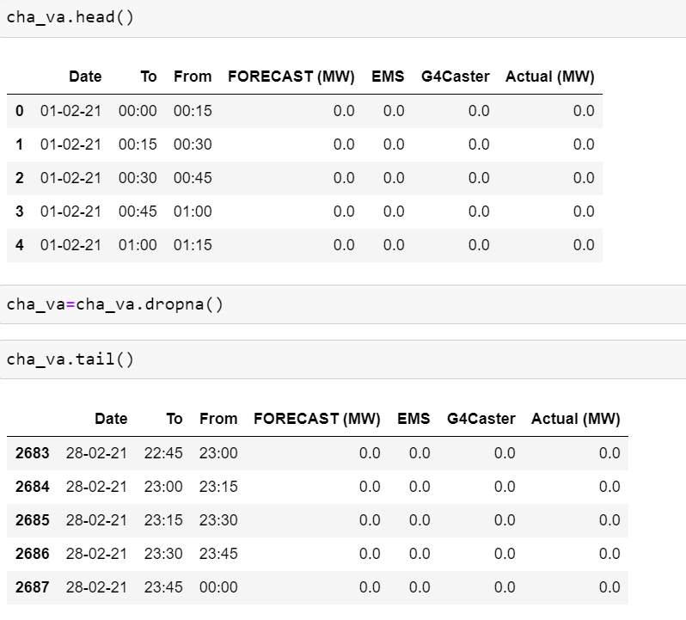For both the Charanka and the Maliya Plant, duplicates were checked and removed:

# Step 2: Fix structural errors

Structural errors are when data is measured or transferred and strange naming conventions, typos, or incorrect capitalization are noticed. These inconsistencies can cause mislabelled categories or classes. For example, “N/A” and “Not Applicable” both appear, but they should be analysed as the same category.

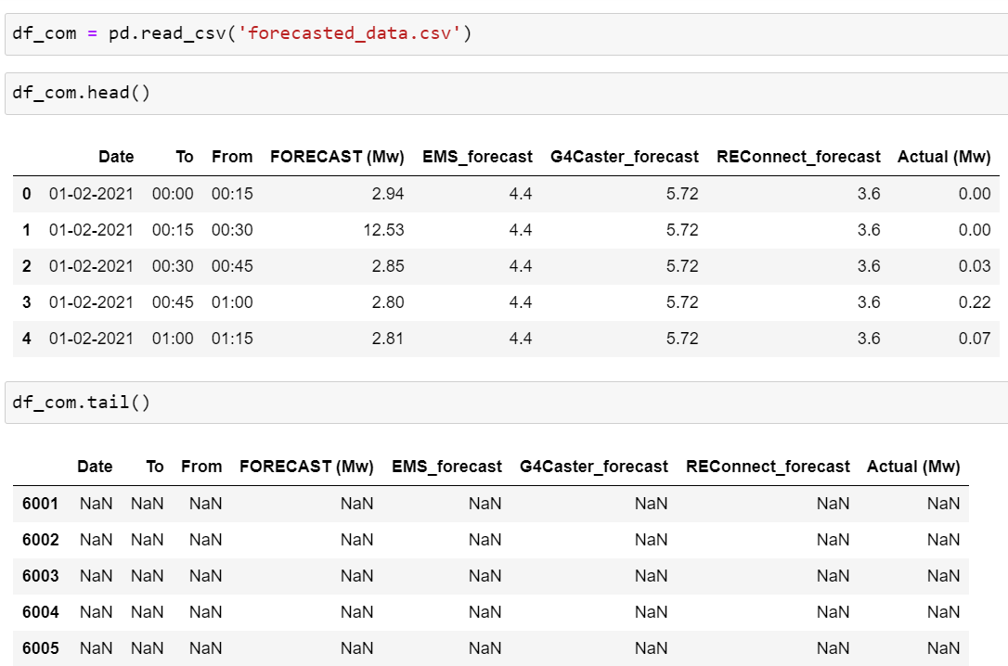

# Step 3: Filter unwanted outliers

Often, there will be one-off observations where, at a glance, they do not appear to fit within the data you are analysing. If you have a legitimate reason to remove an outlier, like improper data-entry, doing so will help the performance of the data you are working with. However, sometimes it is the appearance of an outlier that will prove a theory you are working on.

Just because an outlier exists, doesn’t mean it is incorrect. This step is needed to determine the validity of that number. If an outlier proves to be irrelevant for analysis or is a mistake, one must consider removing it.

As the data in this case is of forecasted power, the outliers are not removed but analysed as to what factors might have influenced the outlier.

# Step 4: Handle missing data

Missing data cannot be ignored because many algorithms will not accept missing values. There are a couple of ways to deal with missing data. Neither is optimal, but all can be considered.

As a first option, observations that have missing values can be dropped, but doing this will drop or lose information, so it is important to be mindful in removing these values.

As a second option, missing values based on other observations can be inputted in; again, there is an opportunity to lose integrity of the data because of operating from assumptions and not actual observations.

As a third option, he way the data is used can be altered to effectively navigate null values.

In the case of this dataset, neither dataset had missing values. All the null values occurred due to the use of an excel workbook to store data; all the null values were dropped.

# Step 4: Validate and QA

At the end of the data cleaning process, you should be able to answer these questions as a part of basic validation:

1. Does the data make sense?

The dataset for the solar power plant had data points or Actual Power values and Forecasted Power values very close to one another indicating a relation between the two and indicating scope to draw conclusions further.

The dataset for the wind power plant had very little to no correlation between the Actual Power generation values and the forecasted power generation values. However, it does not mean that the data does not make any sense. When the actual values were correlated to the wind speed and wind direction values the reason for the Actual Power generated data seemed more likely.

1. Does the data follow the appropriate rules for its field?

The dataset for the solar power plant contains datapoints that follow the rules of the field. For example, both the Actual Power Plant and Forecasted Power Plant contained ‘0’ values during the non-sunny hours of a day and increased in generation power until the afternoon time which is considered peak generation time for solar power plants and then slowly decreased as the day progressed. This way, the data aligns very well with the expected trajectory of a Solar Power Plant.

It was more complicated with the dataset for a wind power plant. As the wind direction and speed are unpredictable the Actual Power generated never aligned strongly with the predicted power generation. Here it was important to reassess the rules that apply to the Wind Power Plant. It was essential to take into consideration behaviour of the wind and not completely depend on previous metrological data.

1. Does it prove or disprove your working theory, or bring any insight to light?

The dataset for the solar power plant showed strong correlation between the Actual Power and Forecasted Power, proves the accuracy of solar power prediction to a profitable extent. The dataset for the wind power plant provides useful insights to the deviation and unpredictability of wind direction and speed.

1. Can you find trends in the data to help you form your next theory?

Plotting both the Charanka and Maliya dataset express trends that are helpful in forming data visualizations and drawing conclusions from. Both the trends are greatly useful, meaningful insights can be derived from them.

1. If not, is that because of a data quality issue?

Fortunately, in both the data sets there have been no data quality issues.

False conclusions because of incorrect or “dirty” data can inform poor business strategy and decision-making. False conclusions can lead to an embarrassing moment in a reporting meeting when the data collected doesn’t stand up to scrutiny.

**Data Exploration and Data visualization**

Solar Power Plant

In order to make the data more workable, a few columns were altered. A new column called “Period” was introduced by concatenating the Date and 15 minute Time interval periods.



Furthermore, for the first Analysis only the Period, Actual Power and Forecast Power columns were used.

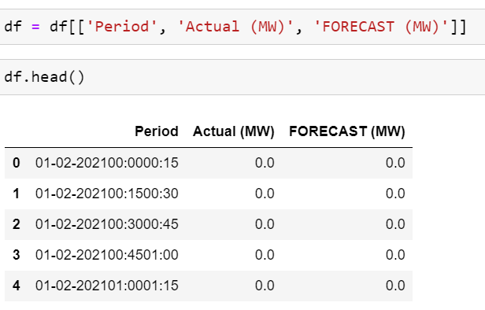

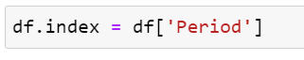Period was established as an Index to give the data some structure and to make it more systematic.

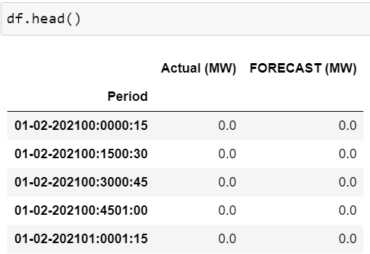

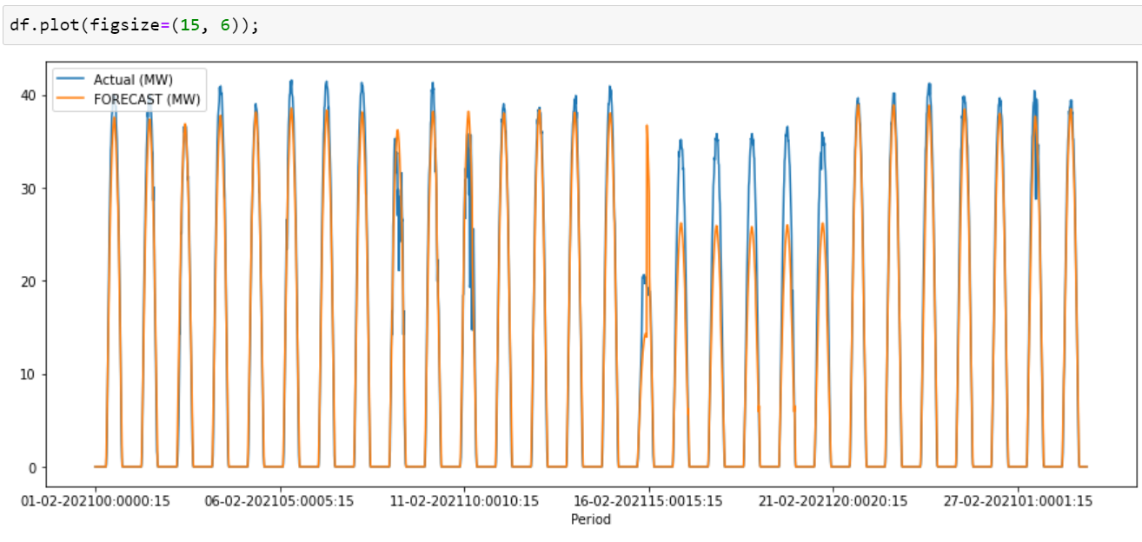The data was then plotted in a line graph

A similar procedure was followed to plot the following Forecast Powers:

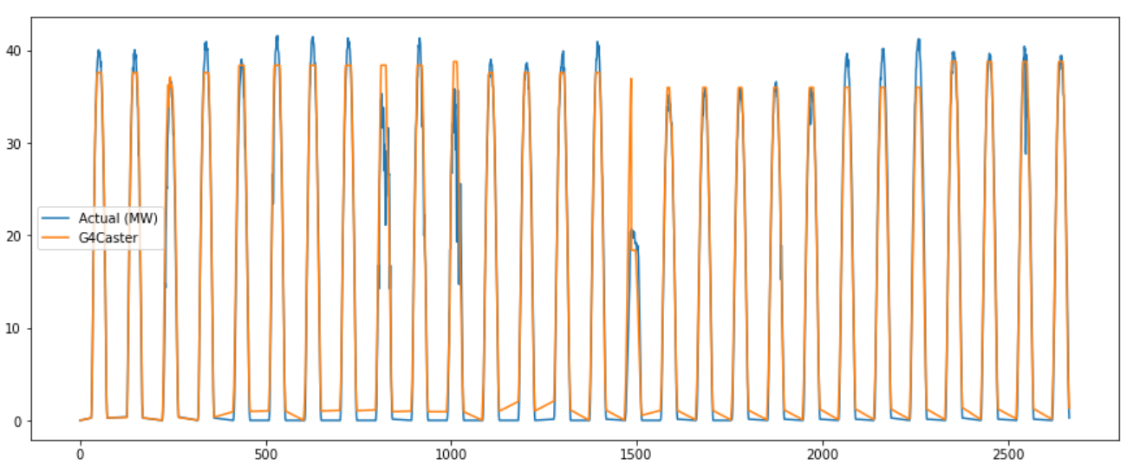 Actual Power Generation vs G4 Forecast Power Generation

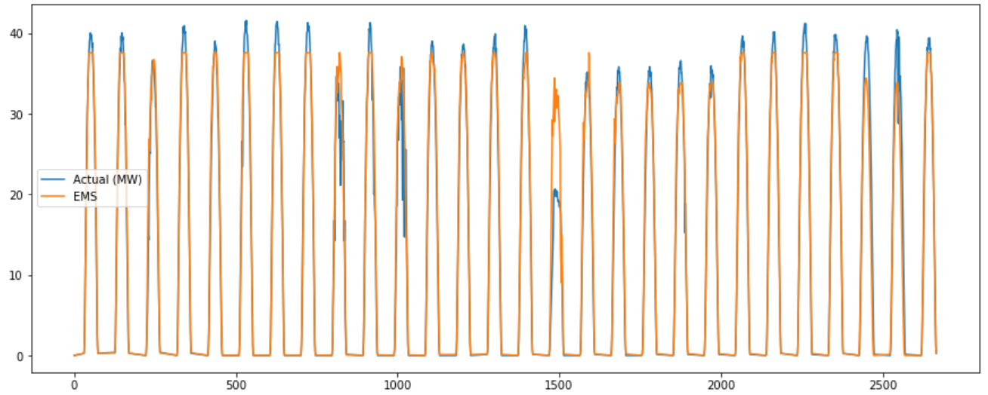 Actual Power Generation vs EMS Forecast Power generation

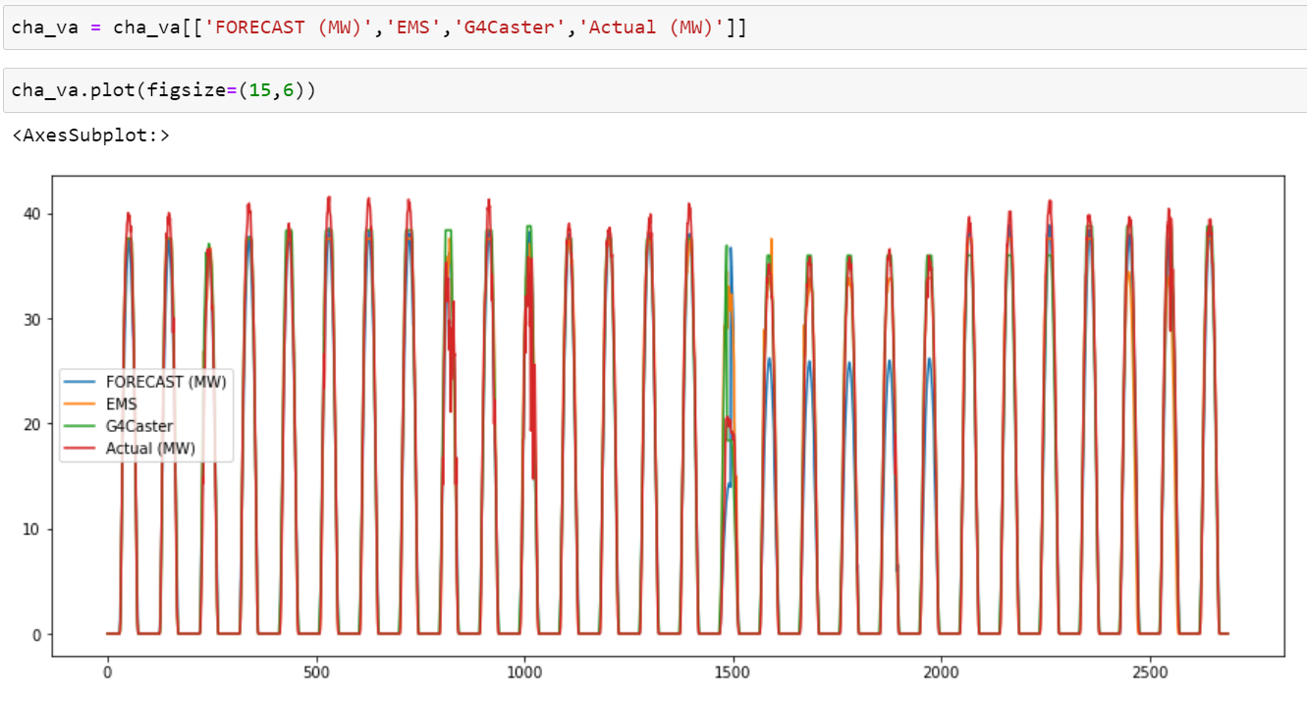A Final plot depicting all three types of Forecast: Forecast, EMS Forecast and G4 Forecast on one graph

In order to answer the questions raised in the problem statement, a few mathematical parameters were calculated for each of the different Forecasts.

Examples of Python code to find Mean Absolute Error, Mean square Error, Root Mean Square Error and the Correlation Coefficient:

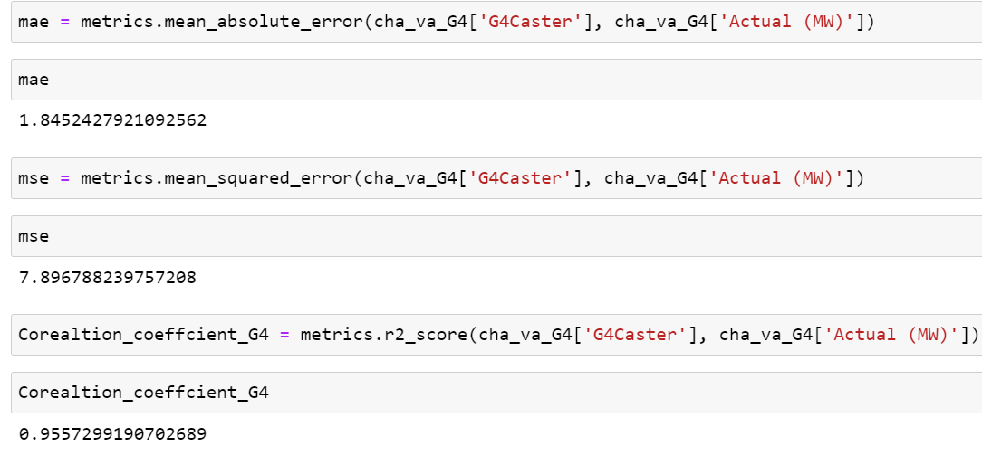

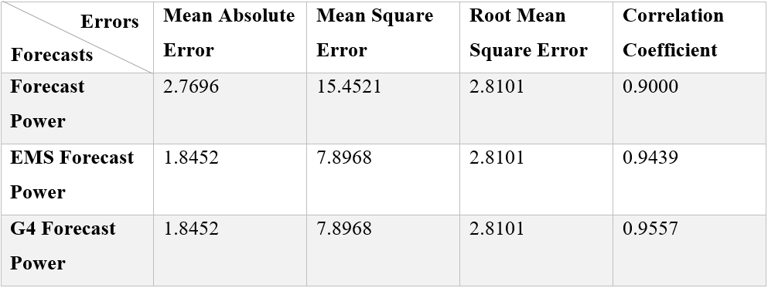

Similarly, the dataset for the Wind Power Plant Maliya was also plotted and explored. Like before, in order to make the data more workable, a few columns were altered. A new column called “Period” was introduced by concatenating the Date and 15-minute Time interval periods. The entire dataset was also checked for null values

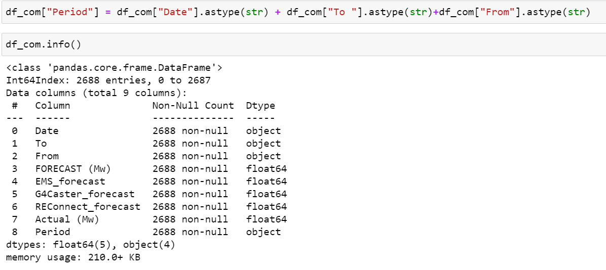

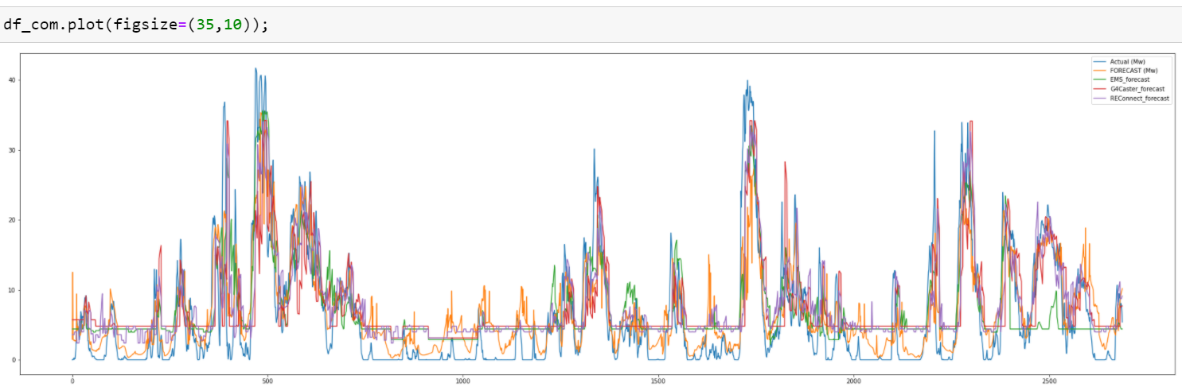For the initial Analysis all the columns: Actual Power Generated, Forecasted Power, EMS Forecasted Power, G4 Forecasted Power and Reconnect Forecasted Power were plotted.

To find more conclusive insights, each of the Forecasted Powers were individually plotted:

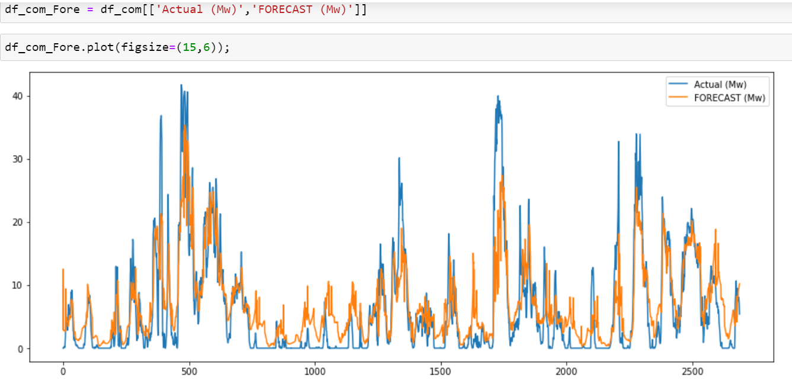Actual Power vs Forecasted Power

Actual Power vs EMS Forecasted Power

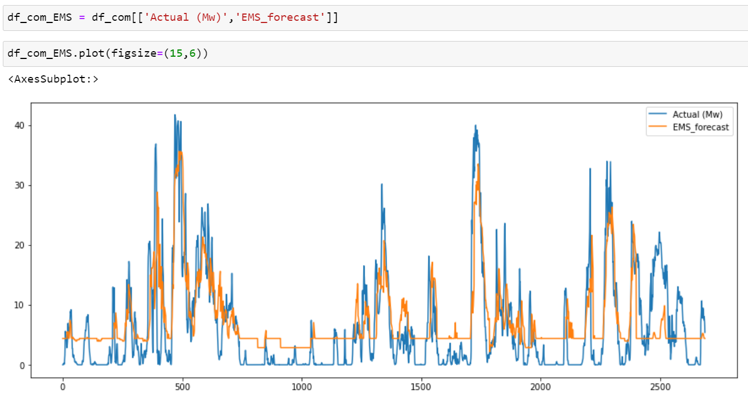

Actual Power vs G4 Caster Forecast

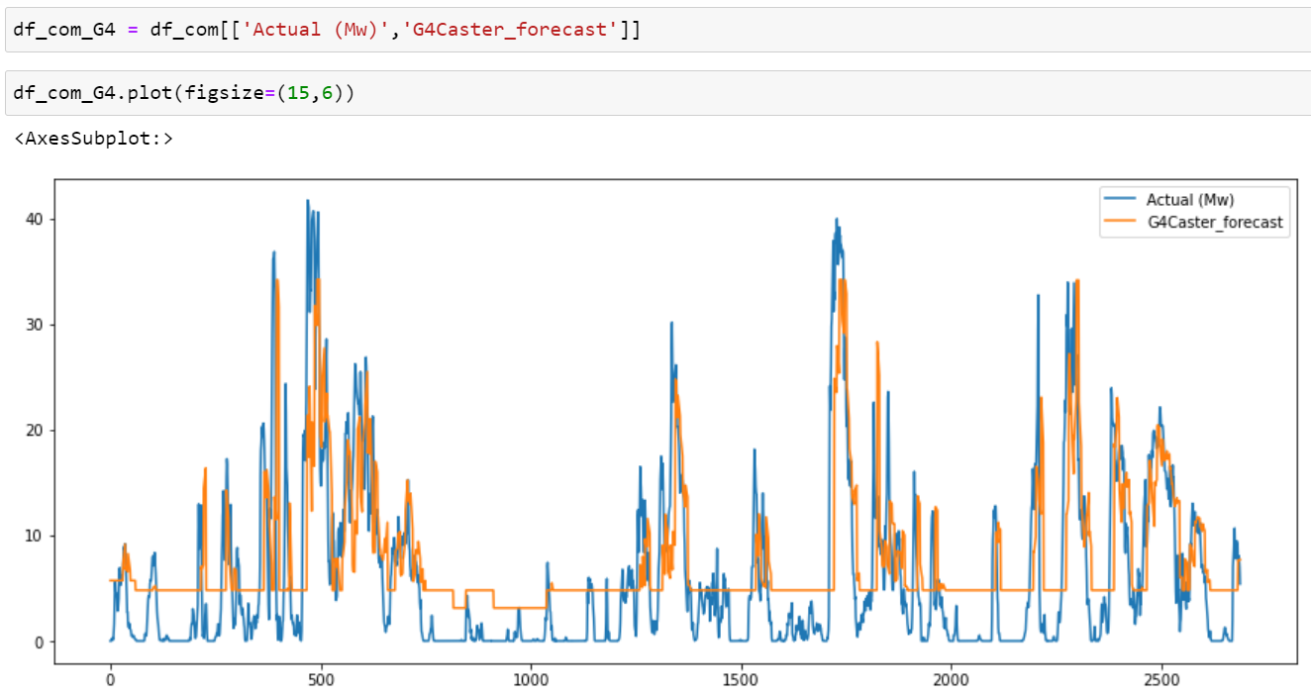

Actual Power vs Reconnect Forecast

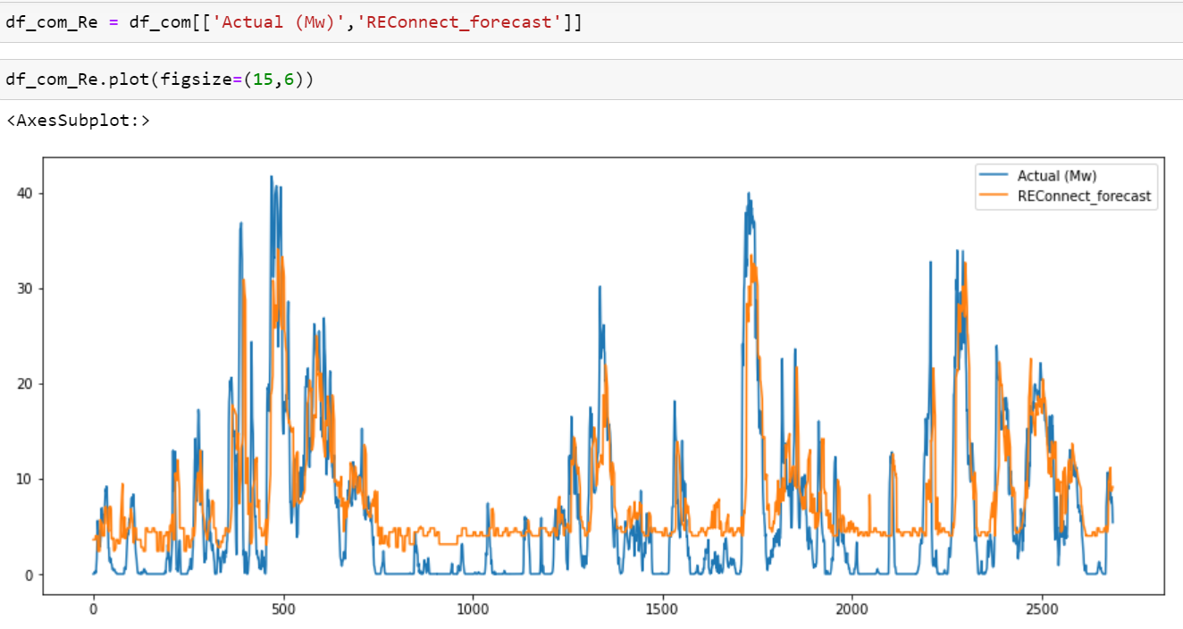

To draw more meaningful insights from the trends, a few mathematical parameters were calculated for each of the columns mentioned above.

The Parameters were achieved through Python code as shown in an example below:

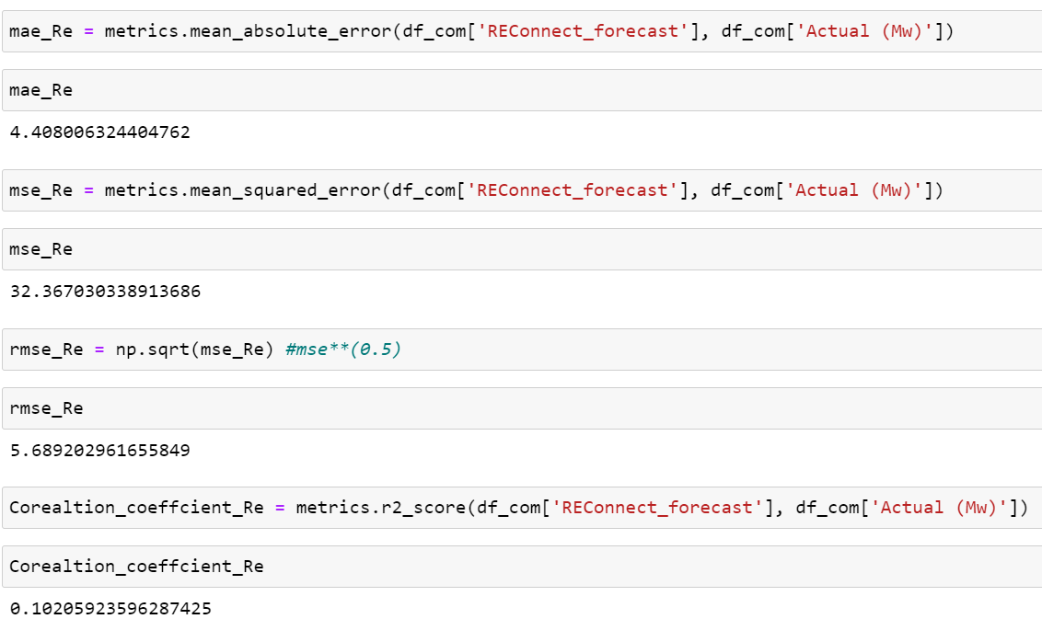

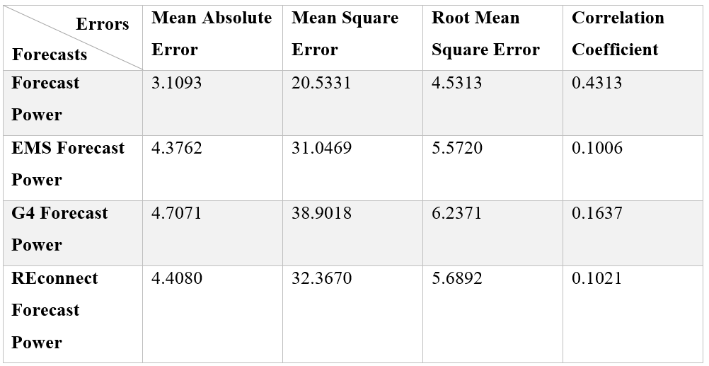

**Observations and Conclusions**

Exploring the Mathematical Parameters:

The simplest measure of forecast accuracy is called Mean Absolute Error (MAE). MAE is simply, as the name suggests, the mean of the absolute errors. The absolute error is the absolute value of the difference between the forecasted value and the actual value. MAE tells us how big of an error we can expect from the forecast on average.

The Solar Power Plant had an MAE of 2.7696, 1.8452 and 1.8452 from the Forecasts: Forecast Power, EMS Forecast Power and G4 Forecast Power respectively. The small values of the MAE suggest that we can expect slight errors from the forecast on an average and this is proven true as the forecast datasets carried very few deviations from the Actual Power Dataset.

The Wind Power Plant had an MAE of 3.1093, 4.3762, 4.7071, 4.4080 from the Forecasts: Forecast Power, EMS Forecast Power and G4 Forecast Power and REconnect respectively. These values suggest a rather large deviation of the Forecasted Power from the Actual Power generated. The dataset obtained from the Forecasted Powers as well as the trends plotted suggest a quite significant deviation as well.

In statistics, the mean squared error (MSE) of an estimator measures the average of the squares of the errors — that is, the average squared difference between the estimated values and what is estimated. The MSE is a measure of the quality of an estimator — it is always non-negative, and the smaller the MSE, the closer we are to finding the line of best fit.

The Solar Power Plant had an MSE of 15.4521, 7.8948 and 7.8968 from the Forecasts: Forecast Power, EMS Forecast Power and G4 Forecast Power respectively. The Wind Power Plant had an MSE of 20.5331, 31.0469, 38.9018, 32.3670 from the Forecasts: Forecast Power, EMS Forecast Power and G4 Forecast Power and REconnect respectively. The comparatively smaller values of the solar power plant MSE suggest that we are closer to finding a line of best fit compared to the wind power plant but still nowhere completely close. This could be a result of the time series nature of the graphs, which do not tailor to a straight line of best fit. The values of the wind power plant being significantly higher than the solar power plant suggest a weaker significance between the Actual Power values and the Forecasted Power Values.

Root Mean Square Error (RMSE) tells us that our model was able to forecast the average daily Power Generated in the test set within 4.531 of the Actual Power for the Wind Power Plant Maliya and within 2.8101 of the Actual Power of the Solar Power Plant Charanka.

The correlation coefficient is a number between 0 and 1. If there is no relationship between the predicted values and the actual values the correlation coefficient is 0 or very low indicating that the predicted values are no better than random numbers. As the strength of the relationship between the predicted values and actual values increases the value of the correlation coefficient increases toward 1.0. A perfect fit gives a coefficient of 1.0. Thus, the higher the correlation coefficient the better.

For the Solar power plant, the coefficient gives a near perfect value of 0.9000, 0.9439 and 0.9557 for the forecasts: Forecast Power, EMS Forecast Power and G4 Forecast Power respectively. The 0.1 deviation can be attributed to unpredicted changes in irradiance, a cloud shadows, dust and grass shadows on the module that could contribute to the Actual Power generated values to be less than the Forecasted Power. On the other hand, on certain days, the Actual Power was comparatively higher than the Predicted Power which can be attributed to the having maximum peak generation due to possible ideal conditions present on that particular day.

The wind power plant has a coefficient of 0.4313, 0.1006, 0.1637, 0.1021 for the forecasts: Forecast Power, EMS Forecast Power and G4 Forecast Power and REconnect respectively. EMS Forecast Power and G4 Forecast Power and REconnect respectively all have a weak correlation. A weak correlation means that as one variable increases, there is a lower likelihood of there being a relationship with the second variable. Forecast Power of a correlation coefficient of 0.4 shows a moderate positive correlation. This indicated that as one value increases, there is no tendency for the other value to change in a specific direction. This is very evidently attributed to the unpredictable change in wind speed and wind direction causing a weak correlation between forecasted Power and Actual Power.

**Evaluation and Further Scope of Research**

Limitations of the Mathematical Parameters:

There exist limitations with the mathematical Parameters which intern limit the accuracy of the conclusions made. One problem with the MAE is that the relative size of the error is not always obvious. Sometimes it is hard to tell a big error from a small error. To deal with this problem, we can find the mean absolute error in percentage terms. [Mean Absolute Percentage Error (MAPE)](http://en.wikipedia.org/wiki/Mean_absolute_percentage_error) allows us to compare forecasts of different series in different scales. Since both of these methods are based on the mean error, they may understate the impact of big, but infrequent, errors. If there is more focus on the mean, we will be caught off guard by the infrequent big error.

Quality and Quantity of Data

In time series forecasting there is a general rule of thumb that a decent model should always have more observations than parameters in the time series. For most time series applications, this means that the submitted data should have as many observations as the period of the maximum expected seasonality.

For example, if you have daily Power Generated data and you expect that it exhibits annual seasonality, you should have more than 365 data points to train a successful model. If you have hourly data and you expect your data exhibits weekly seasonality, you should have more than 7*24 = 168 observations to train a model. However, these are the bare minimum number of points needed to train these types of models – more data is required if you want to effectively test how accurately your model performs at making predictions. Your test set should be about 25% the size of your training set. So with a dataset that is expected to exhibit annual seasonality, the minimum number of points required to train and test multiple models is 365 + 365/4 ~ 456 observations.

There should have been more steps taken to check the reliability of data. Reliability refers to the degree to which the data can be trusted. A model trained on a reliable data set is more likely to yield useful predictions than a model trained on unreliable data. In measuring reliability, it must be determined: How common are label errors? For example, if the data is labelled by humans, sometimes humans make mistakes.

Are the features noisy? For example, irradiance measurements fluctuate. Some noise is okay. A dataset cannot be purged of all noise; however, collection of more data is important.

Is the data properly filtered for the problem? For example, should the data set include search queries from government SCADA? If the uncertainty and the deviation were to be properly assessed and detected, then likely the answer is yes, but the goal is to merely point out the results for humans, then no.

Scope of the research

The research identifies the weak correlation and predicting power of a wind power generation. This could be further explored and built upon in either reducing the uncertainty of the wind power generation or estimating the uncertainty in wind power forecasting.

As the intermittence of wind generation causes difficulties in the management of power systems. In the context of the deregulation of electricity markets, wind energy is penalized by its intermittent nature. It is recognized today that the forecasting of wind power for horizons up to 2/3-day ahead eases the integration of wind generation. Wind power forecasts are traditionally provided in the form of point predictions, which correspond to the most-likely power production for a given horizon. That sole information is not sufficient for developing optimal management or trading strategies. Therefore, further investigation on possible ways for estimating the uncertainty of wind power forecasts could be very useful. The characteristics of the prediction uncertainty are described by a thorough study of the performance of some of the state-of-the-art approaches, and by underlining the influence of some variables e.g. level of predicted power on distributions of prediction errors. A generic method for the estimation of prediction intervals can be introduced. This statistical method is non-parametric and utilizes fuzzy logic concepts for integrating expertise on the prediction uncertainty characteristics. By estimating several prediction intervals at once, one could obtain predictive distributions of wind power output. The proposed method could later be is evaluated in terms of its reliability, sharpness and resolution.

One could also look into reducing the uncertainty of wind power predictions, it could define the required size of an energy storage system which is able to compensate completely or partially wind power forecast errors and to estimate its cost. Three probabilistic instruments can be developed to enable the proposed ESS sizing method. One could be a persistence model which permits the generation of large time series of forecast data from measured series of wind power.